ELB

1. Create 4 instances  
   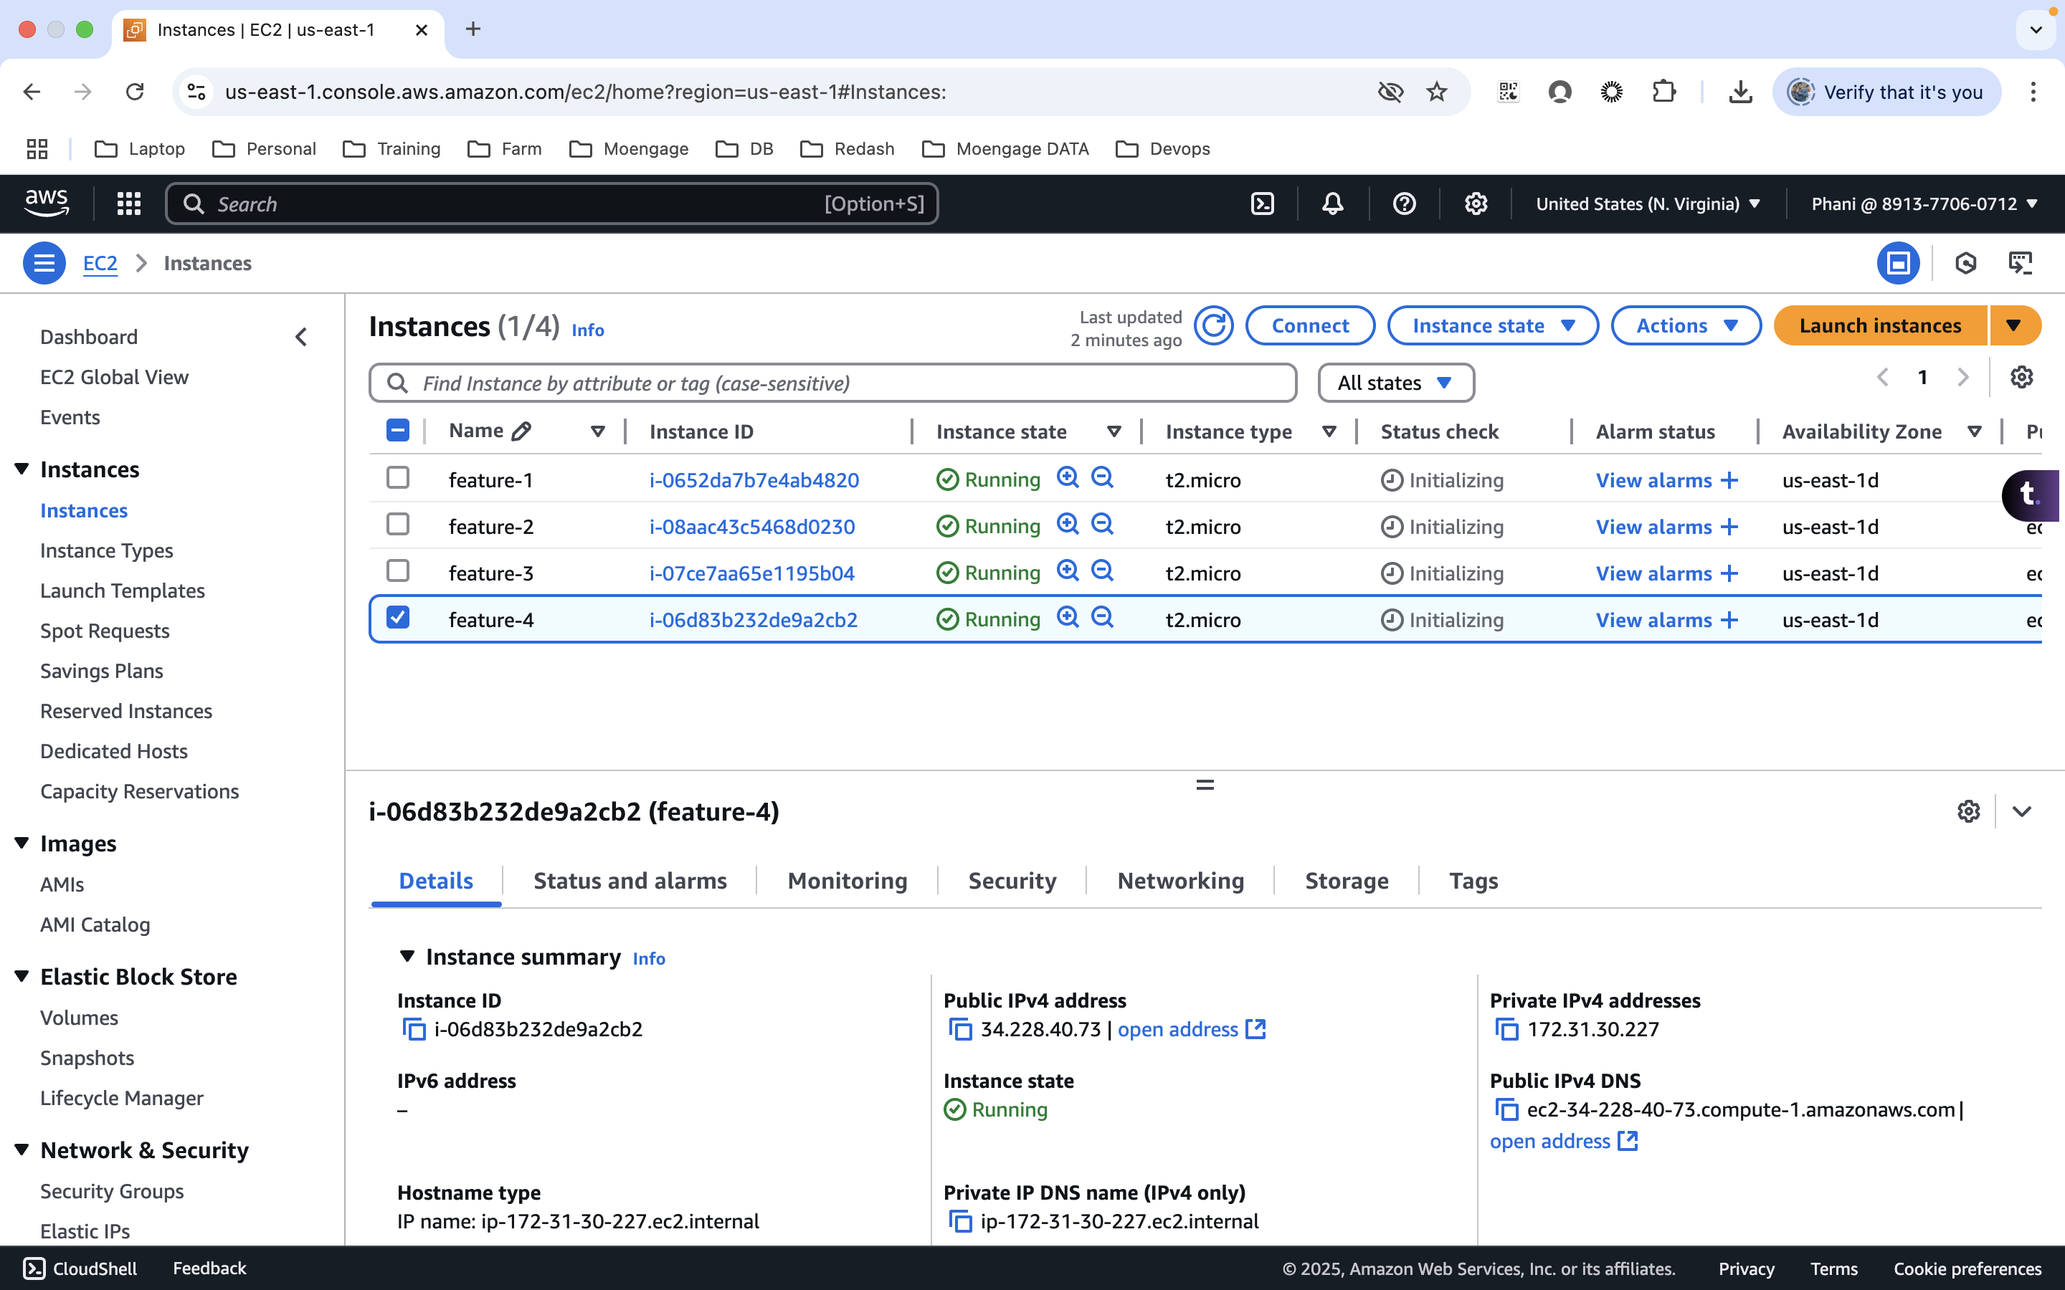
2. Clone the below repo on all the instances  
   git clone <https://github.com/vikas0105/weather-app.git>  
     
   Docker:

feature1 and 2 instance – feature1  
feature2 and 3 instance – feature 2  
  
sudo snap install docker  
sudo docker-compose up --build -d

We can access it from the ip address  
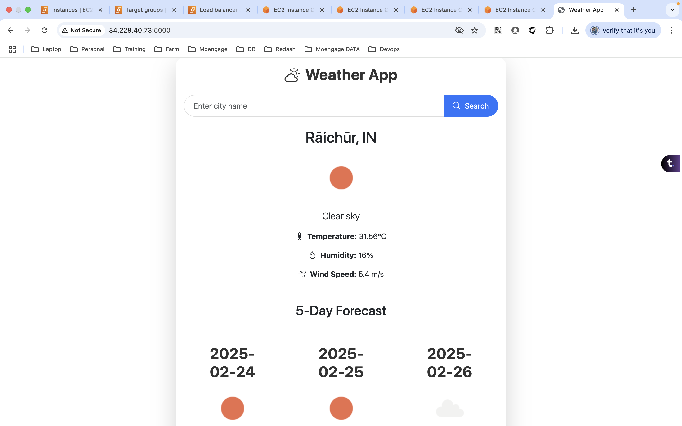

1. Allow 5000 port on all the instances
2. Cretae target group  
   Add instances  
   add 5000 port  
   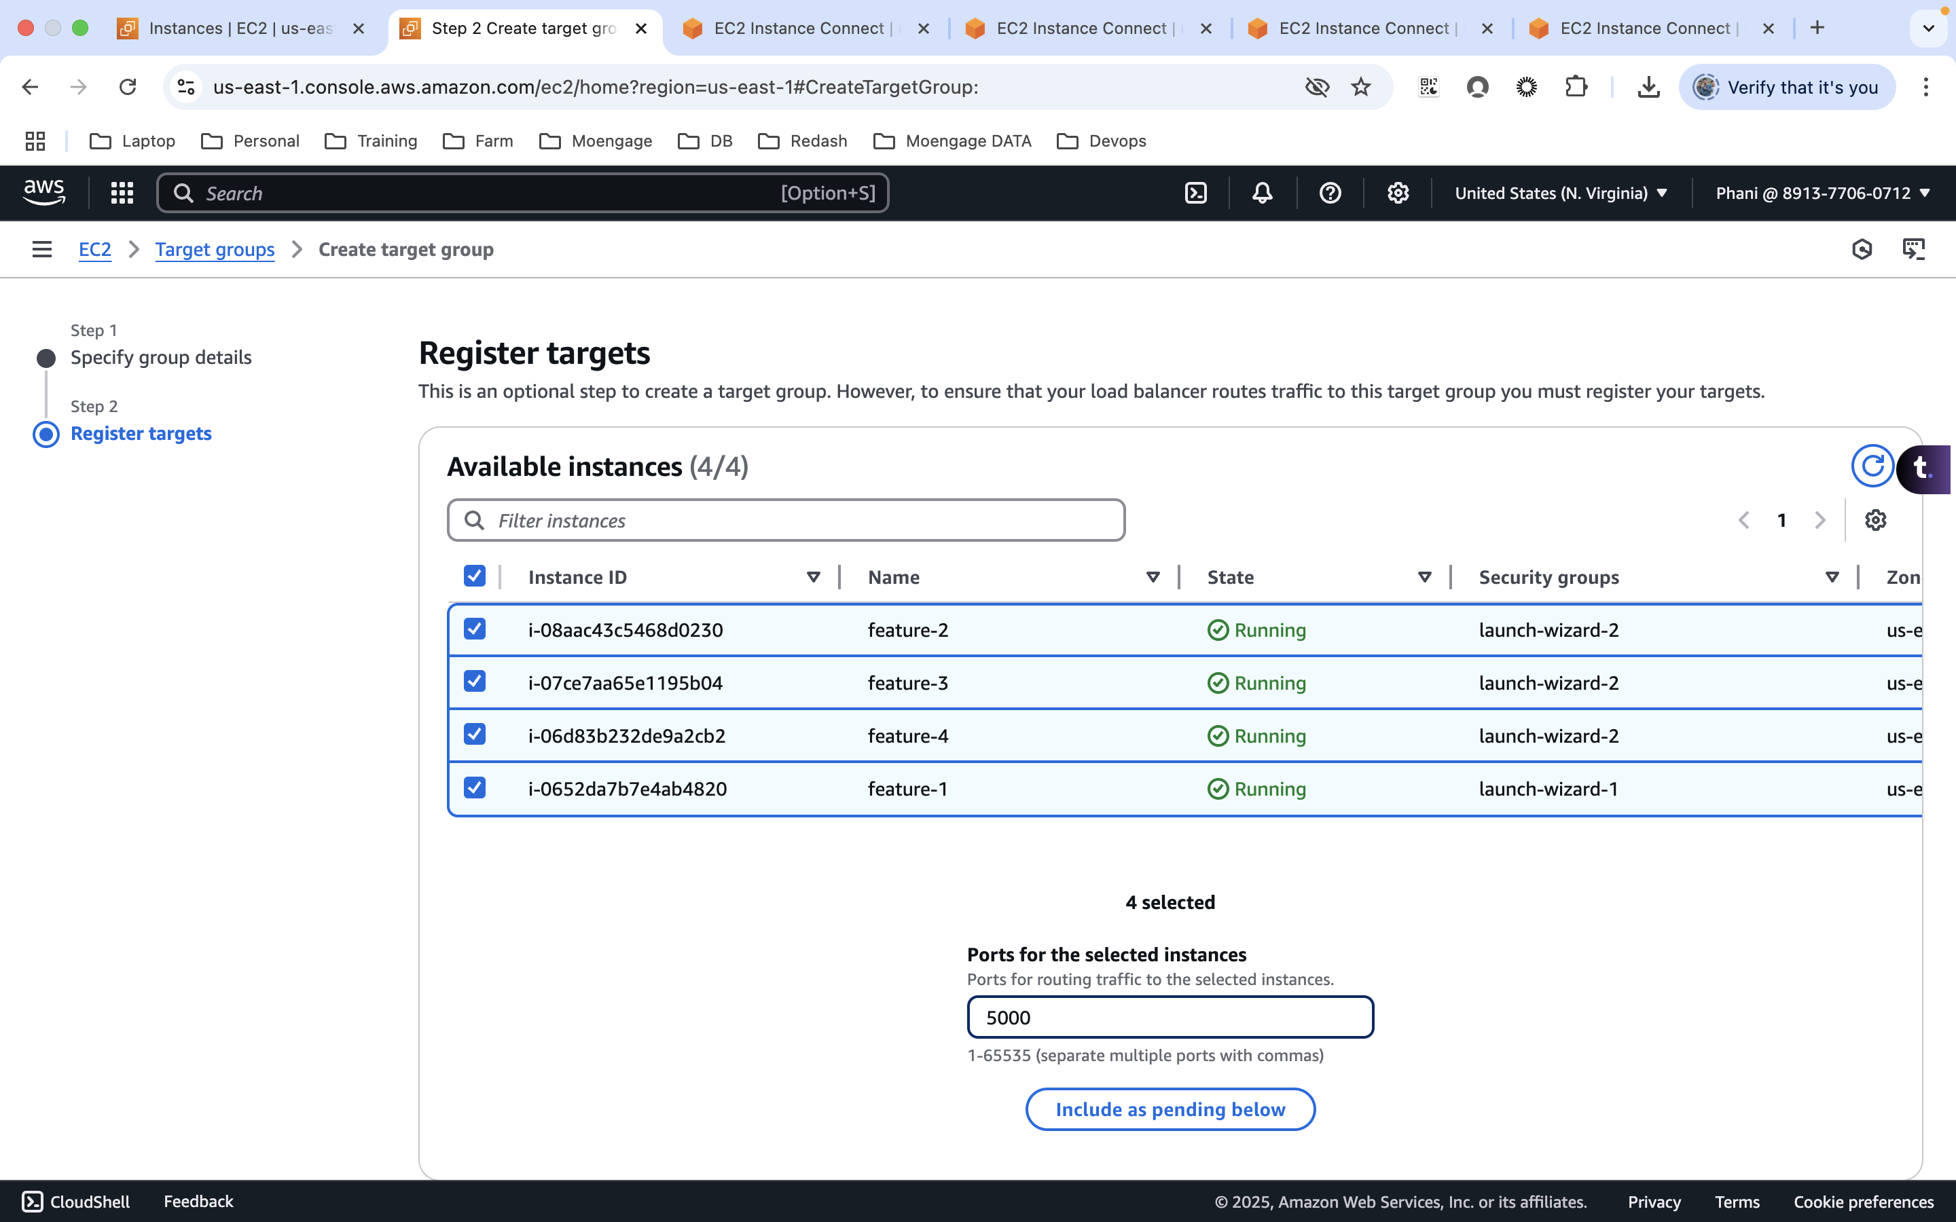
3. Create load balancer  
   Using application load balancer  
   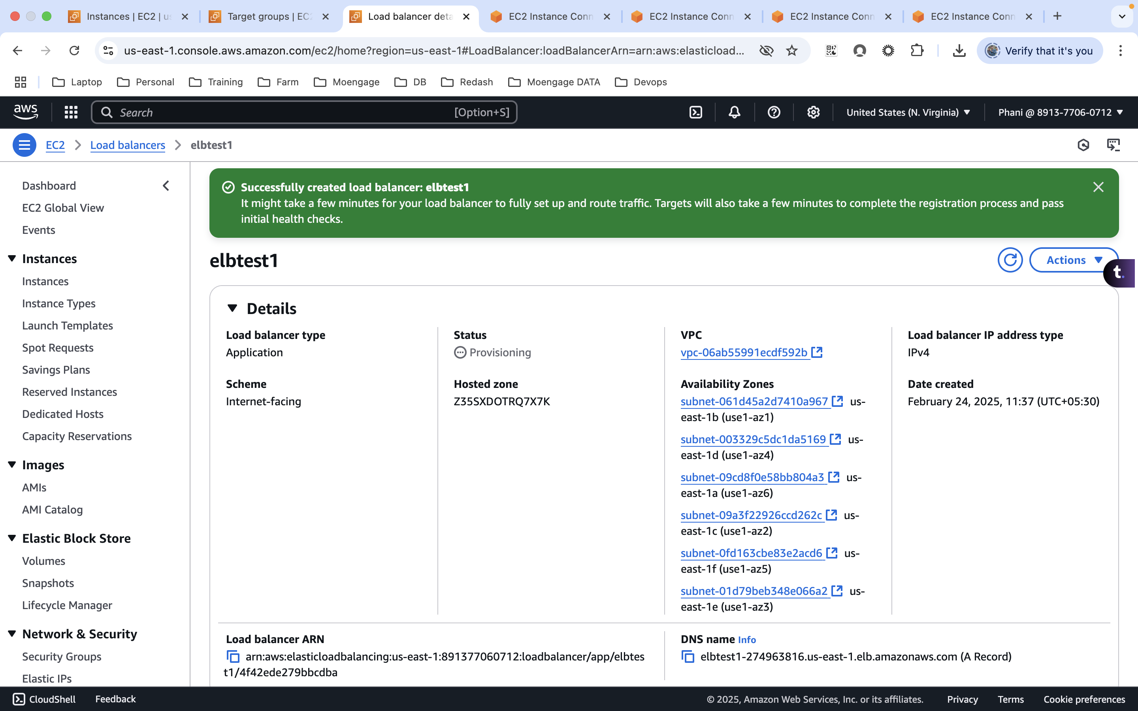
4. Use DNS name to access the site  
   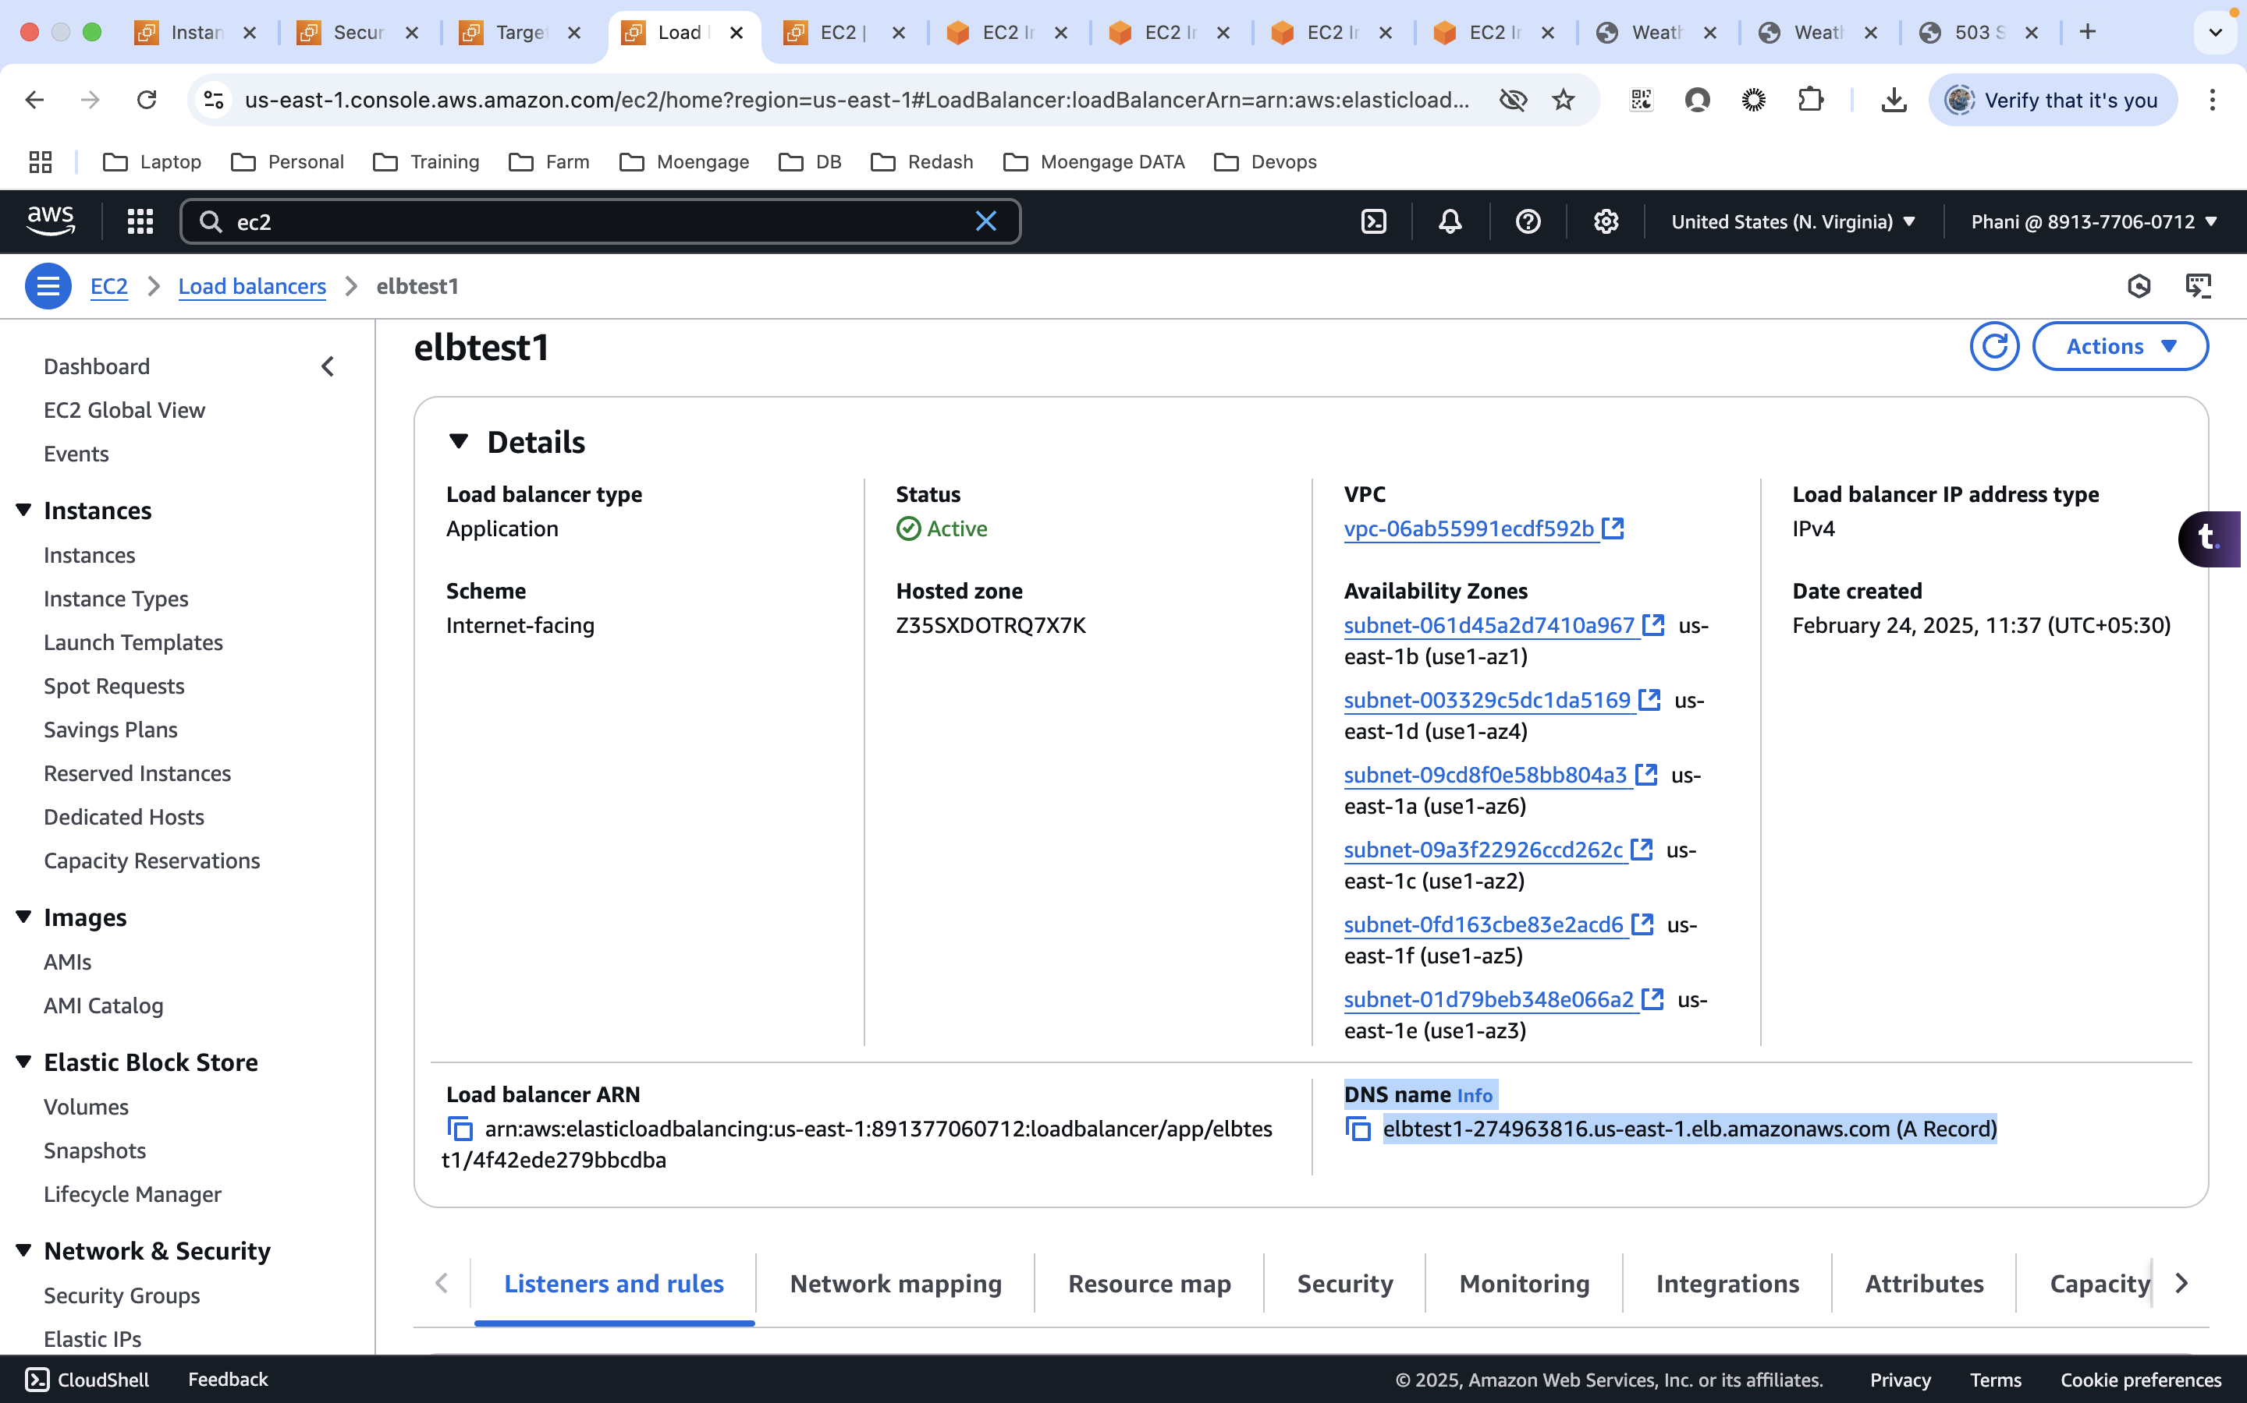  
   A screenshot of a computer

   AI-generated content may be incorrect.  
   A screenshot of a computer

   AI-generated content may be incorrect.